序号：1
矿山  位置 | 江苏省连云港市连云区山后村 |  |  | 采矿损毁  土地编号 |  | WS3207030050050055 |  | 中心  经度 | 119.361628
图斑核定面积 | 27291.38m² |  |  | 历史遗留  图斑编号 |  | ZJ3207032025002001 |  | 中心  纬度 | 34.691713
图斑影像
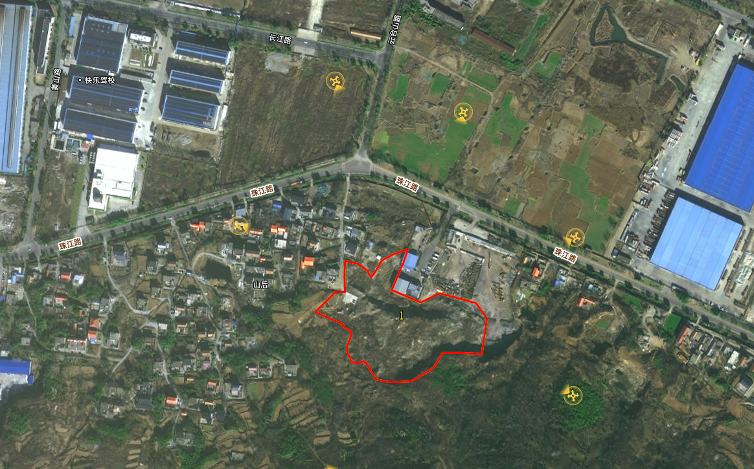
图斑范围主要拐点坐标
序号 |  | 纬度 | 经度 |  | 序号 |  | 纬度 | 经度
1 |  | 119.362362 | 34.692263 |  | 15 |  | 119.360834 | 34.691537
2 |  | 119.362964 | 34.692127 |  | 16 |  | 119.360898 | 34.691677
3 |  | 119.363150 | 34.691914 |  | 17 |  | 119.360893 | 34.691738
4 |  | 119.363063 | 34.691430 |  | 18 |  | 119.360302 | 34.692009
5 |  | 119.362423 | 34.691448 |  | 19 |  | 119.360644 | 34.692281
6 |  | 119.362263 | 34.691247 |  | 20 |  | 119.360799 | 34.692283
7 |  | 119.361900 | 34.691059 |  | 21 |  | 119.360797 | 34.692704
8 |  | 119.361317 | 34.691084 |  | 22 |  | 119.360813 | 34.692702
9 |  | 119.361148 | 34.691321 |  | 23 |  | 119.361239 | 34.692480
10 |  | 119.361100 | 34.691335 |  | 24 |  | 119.361417 | 34.692714
11 |  | 119.361040 | 34.691306 |  | 25 |  | 119.361846 | 34.692862
12 |  | 119.360901 | 34.691334 |  | 26 |  | 119.361578 | 34.692306
13 |  | 119.360835 | 34.691455 |  | 27 |  | 119.362061 | 34.692140
14 |  | 119.362362 | 34.692263 |  | 28 |  | 119.362061 | 34.692140

